**The Ugly Sweater 5K and Santa 1 mile Fun Run/Walk**

The New 5K for Ageless is an Ugly Sweater Run!   Participants are encouraged to wear horrendous holiday sweaters and be entered in a contest for worst dressed.  We are also hosting a 1 mile fun run/walk in which Santa will be jogging with the little ones.  The course itself carries on that fun vibe, too.  The GHS choir will be throughout the race singing Christmas carols. Holiday music will be playing at Ageless, hot chocolate will be provided after the race and Santa will be there to get pictures taken with all the children.  There's one final ingredient to boosting the holiday spirit: helping others. The Ugly Sweater Run benefits families in need during this holiday season.  We are asking participants and anyone in the community to bring a new toy with them to help everyone have a happy holiday.  Part of the proceeds will go to *Joyful Angels*.

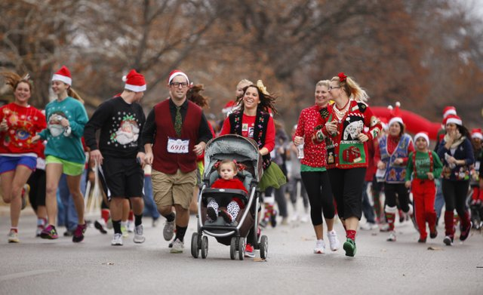

Date:  December 7th&Time: 9:00am

Location:  Ageless, 103 N. Jersey Street

Gillespie, IL 62033

**Cost:  $25.00**

**Includes:  Santa t-shirt, hot chocolate, and fun!**

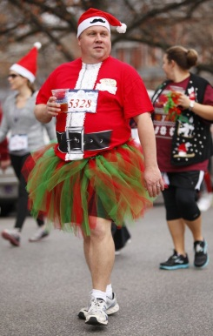

**Ugly Sweater Run 5k and 1 mile Fun Run/Walk**

**Individual Entry Form**

**Name: ___________________________________________________**

**Address: __________________________________________________**

**Phone: ___________________________________________________**

**Email: ___________________________________________________**

**Emergency Contact Name and Phone: ___________________________________**

**Age: ___________ Gender: ______________**

**T-Shirt size: ____________________ (Must be turned by November 25th!)**

In consideration of my being allowed to participate, I assume all risks associated with competing in the Ugly Sweater Run 5K, including but not limited to falls, effects of weather, traffic and conditions of the road, all such risks being known or unknown by me. Having read this release and knowing these facts, and in consideration of your accepting my entry, I for myself and anyone entitled to act on my behalf, waive and release Ageless and the sponsors of this race and other persons associated with the race from all claims and liabilities of any kind arising out of my participation in the race. I understand that the entry fee is nonrefund-able.

_______________________________________________________ __________________________________

Signature Date

For those 18 and younger:

_______________________________________________________ ___________________________________

Guardian Signature Date